Learn automation teat ng videos

[1.@Test](mailto:1.@Test)

[2.@Test(priority=1)](mailto:2.@Test(priority=1))

**3**.**skip test case**

@Test(enabled=false)

**4.depandent**

@Test(dependsonmethods=”which method depent”)

**5.time calculate**

Long st=system.currenttimemillis();

Long et= system.currenttimemillis();

Long total=et-st;

**6.xml file**

<suite name=”test suite “ verbose=”2”>

<test name=”test”>

<classes>

<class name=”package name.classname>

</class>

</classes>

</test>

</suite>

**7.grouping**

<suite name=”test suite “ verbose=”2”>

<test name=”test”>

<groups>

<include name=”which”>

<run>

</run>

</groups>

<classes>

<class name=”package name.classname>

</class>

</classes>

</test>

</suite>

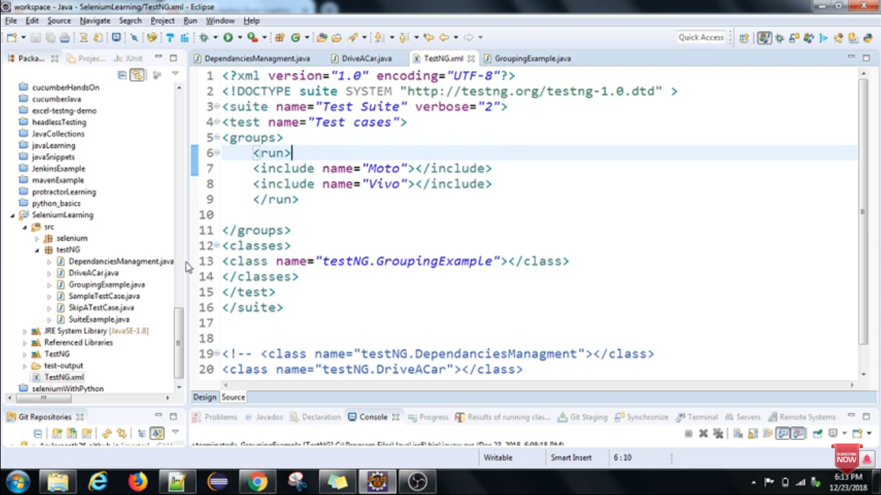

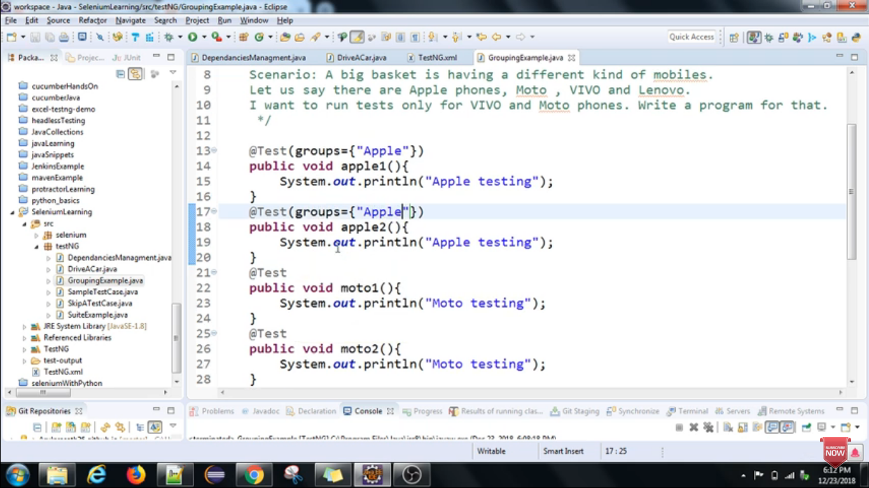

**8.parameteraization**

Pass the parameter in methods using xml file

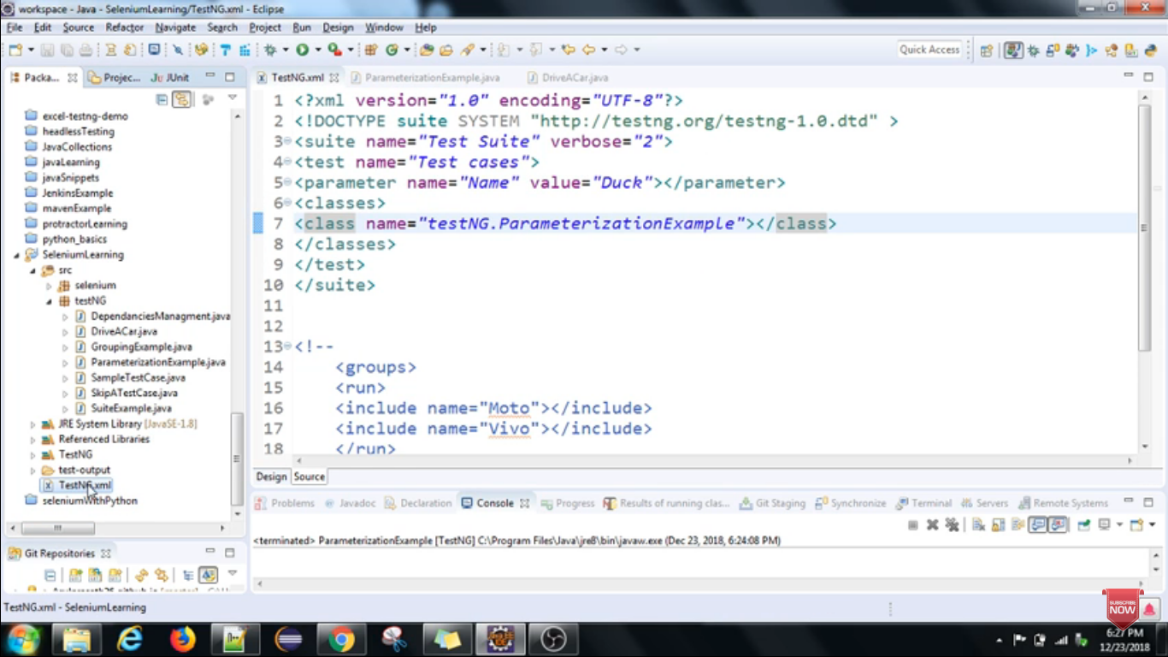

Xml la enna name o atha inga kudukkanum automatic aa value eduthukkum

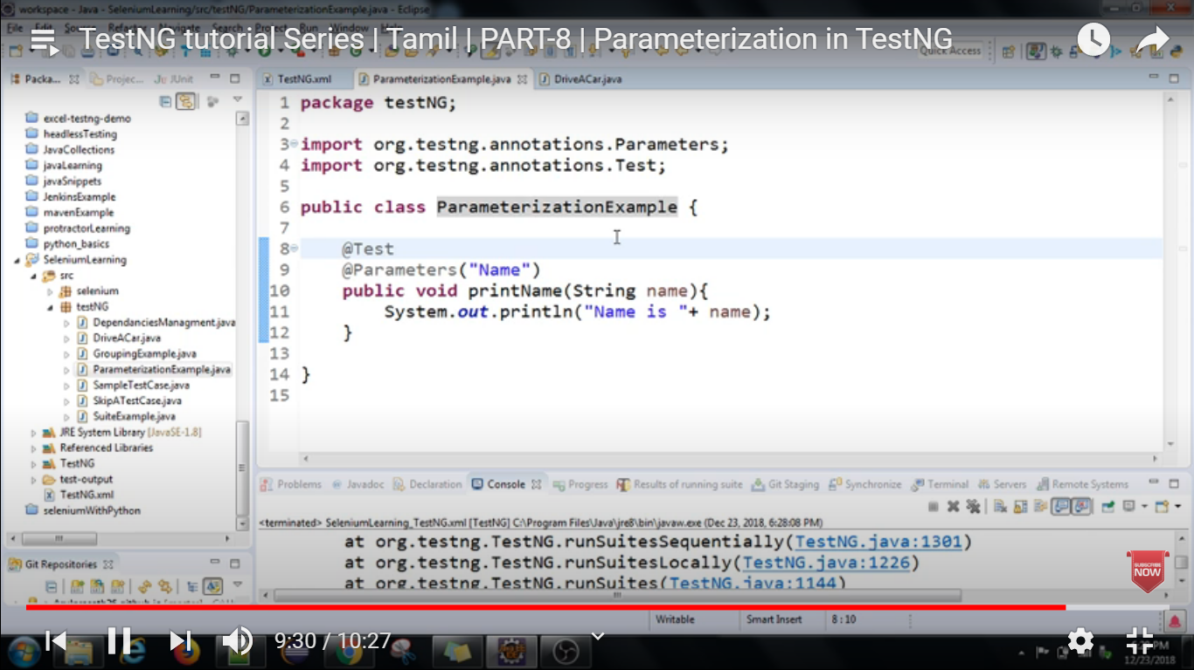

**9.parallel**

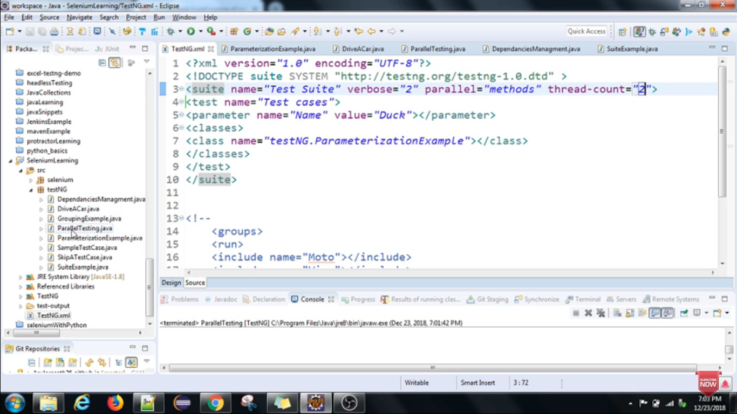

**10.assert**

Mostly using unit test developer

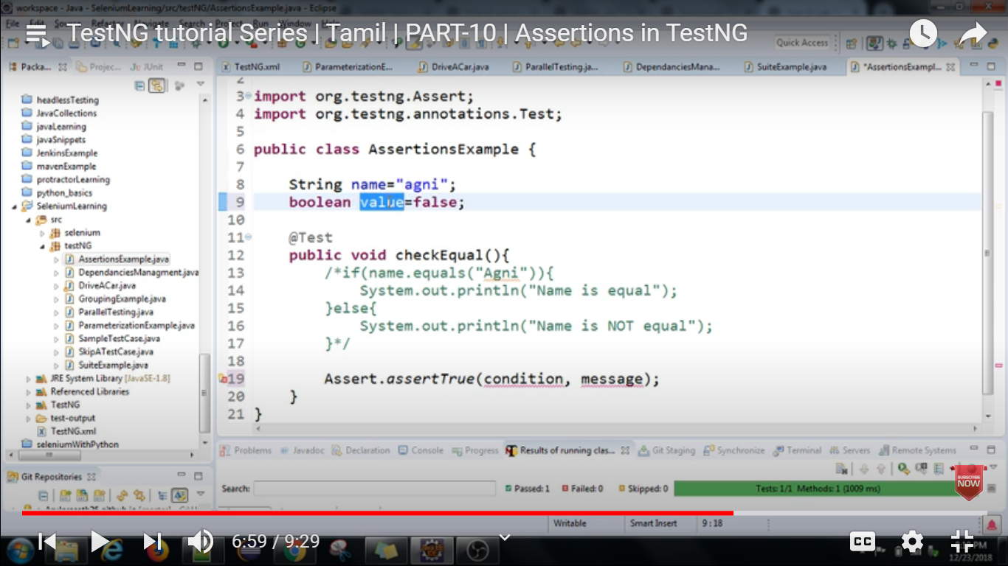

**11.annotation order**

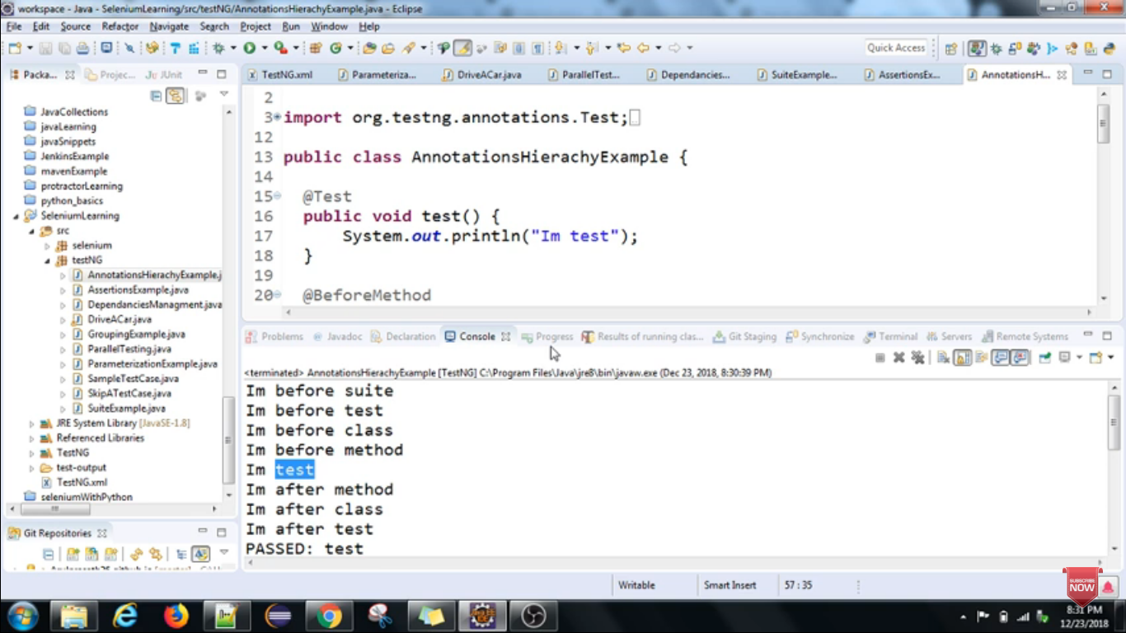

**12.listener**

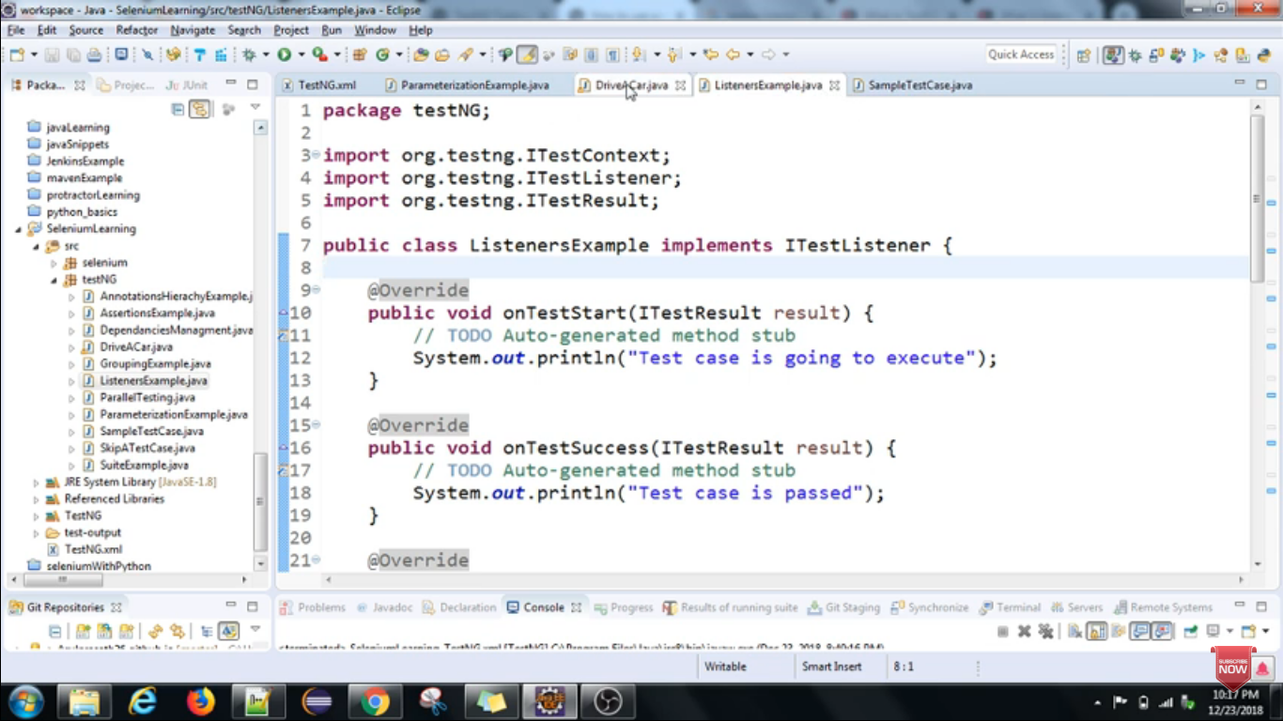

1. **public** **class** Listener **implements** ITestListener
2. {
3. @Override
4. **public** **void** onTestStart(ITestResult result) {
5. // TODO Auto-generated method stub
6. }
8. @Override
9. **public** **void** onTestSuccess(ITestResult result) {
10. // TODO Auto-generated method stub
11. System.out.println("Success of test cases and its details are : "+result.getName());
12. }
14. @Override
15. **public** **void** onTestFailure(ITestResult result) {
16. // TODO Auto-generated method stub
17. System.out.println("Failure of test cases and its details are : "+result.getName());
18. }
20. @Override
21. **public** **void** onTestSkipped(ITestResult result) {
22. // TODO Auto-generated method stub
23. System.out.println("Skip of test cases and its details are : "+result.getName());
24. }
26. @Override
27. **public** **void** onTestFailedButWithinSuccessPercentage(ITestResult result) {
28. // TODO Auto-generated method stub
29. System.out.println("Failure of test cases and its details are : "+result.getName());
30. }
32. @Override
33. **public** **void** onStart(ITestContext context) {
34. // TODO Auto-generated method stub
35. }
37. @Override
38. **public** **void** onFinish(ITestContext context) {
39. // TODO Auto-generated method stub
40. }
41. }

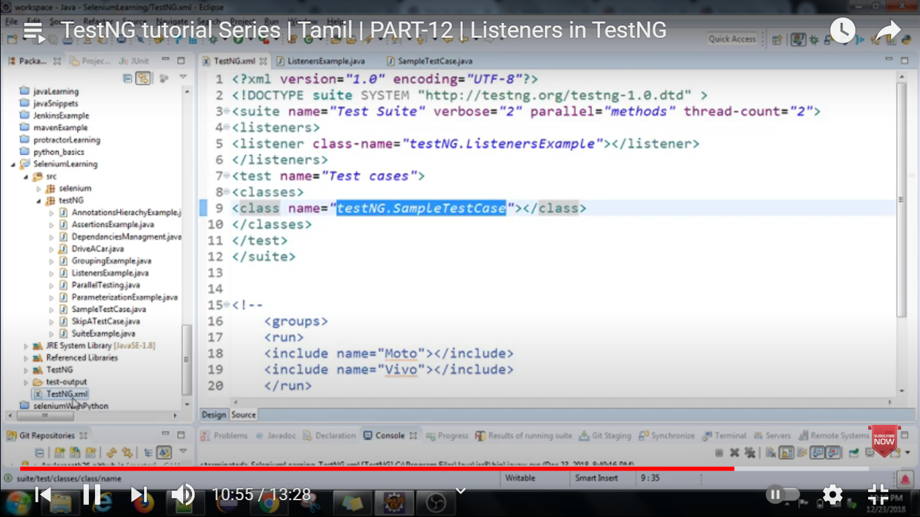

**Data provider**

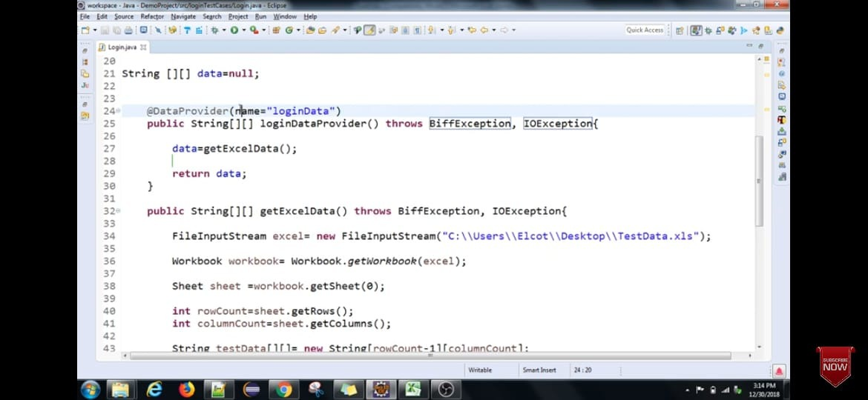

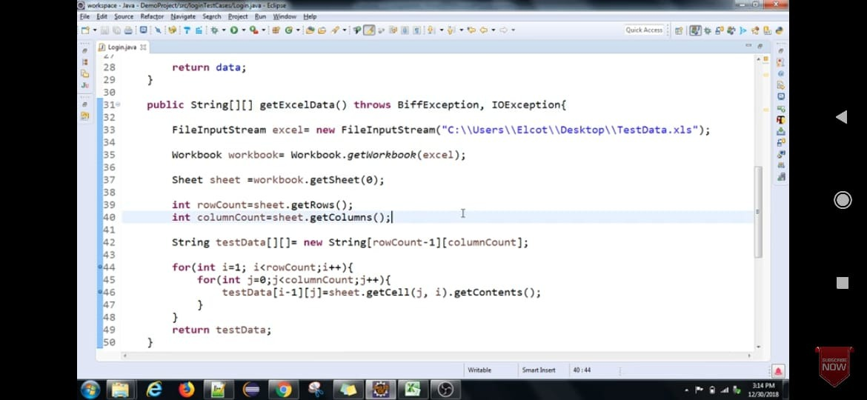

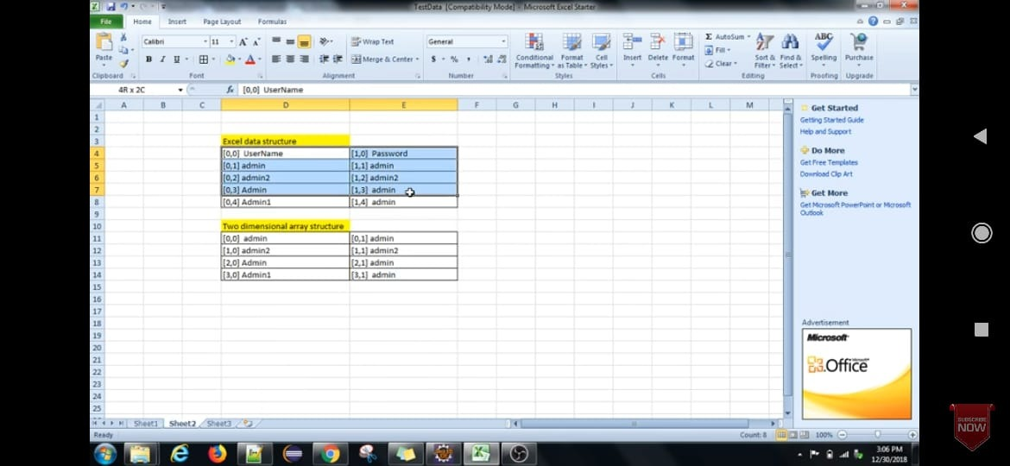

## Testng Hierarchy

